Article

**Preparation of cuttlefish ink-porphyrin nanoconjugates and its application in photodynamic-photothermal synergistic treatment of tumor cells**

**Supplementary materials**

**Experimental materials and instruments**

Tetrakis (4-carboxyphenyl) porphyrin (TCPP), 97% purity, N-Hydroxysulfosuccinimide (NHS), 98% purity and 1-(3-Dimethylaminopropyl)-3-ethylcarbodiimide hydrochloride (EDC), 95% purity, all purchased from Shanghai Maclin Biochemical Technology Co., LTD. N, N-dimethylformamide (DMF), analytically pure and 1.3-diphenyl isobenofuran (DPBF), with a purity of 97%, were purchased from Shanghai Sinophosphoric Chemical Reagents Co., LTD. Cell counting kit-8 (CCK-8), Calcein-AM and propidium iodide (PI) were purchased from Beyotime Biotechnology. Cuttlefish were purchased from a seafood market, and ink was extracted from their ink sacs. The ink was then thoroughly washed multiple times with a water/ethanol solution to obtain the cuttlefish ink nanoparticles used in this experiment.

JSM-7500F scanning electron microscope (Japan Electron, SEM, 10 kV); Shimadzu UV-2600 Ultraviolet-Visible Spectrophotometer (UV-vis), Shimadzu Company, Japan; Hitachi F-4600 Fluorescence Spectrometer, Hitachi Corporation, Japan; NANOTRAC WAVE Ⅱ Nano Particle Size and ZETA Potential Analyzer, Microtrac, USA; HIKMICRO handheld thermograph, Hangzhou Micro Film Software Co., LTD.

**Supplementary figures**

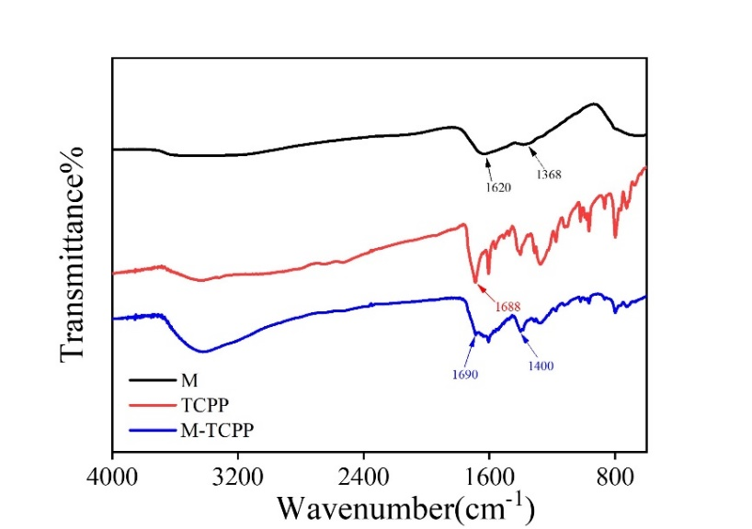

**Figure S1.** FTIR spectra of M, TCPP and M-TCPP.

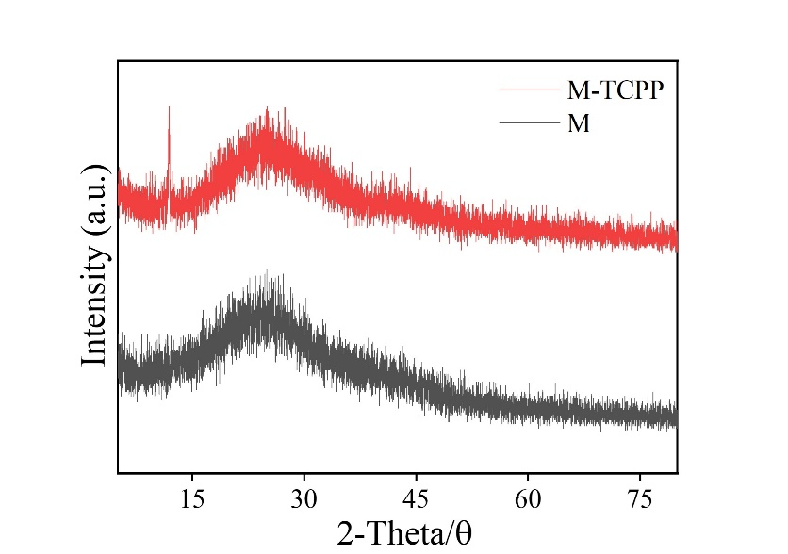

**Figure S2.** XRD spectra of M and M-TCPP.

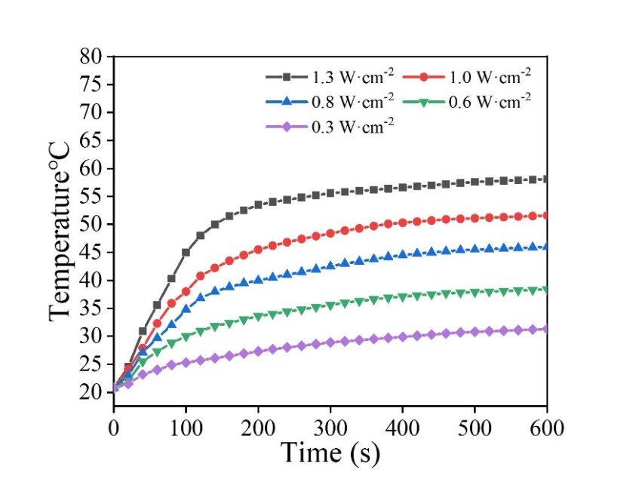

**Figure S3.** Photothermal effect under different laser power.

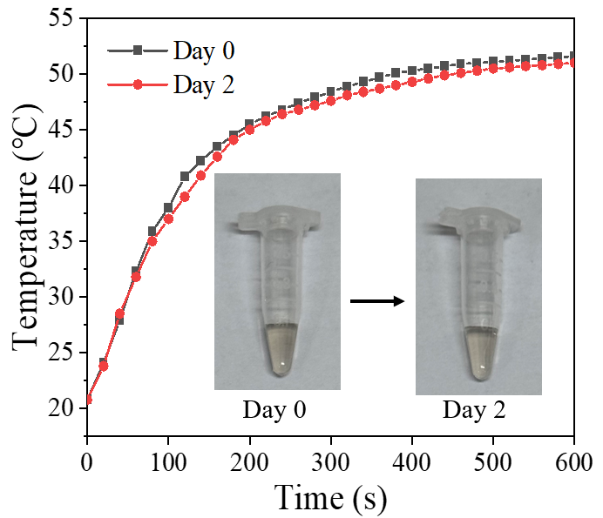

**Figure S4.** Stability assessment of M-TCPP.