Article

**Effective Nano-manufacturing of T-Nb2O5 for supercapacitor applications**

**Supplementary materials**

**Figure S1.** The cyclic stability and coulombic efficiency plot the T-Nb2O5-based SSD.

**Figure S2.** The fitted Randles circuit of the Nyquist plot (as shown in Figure 3(d)) of the fabricated T-Nb2O5-based SSD.

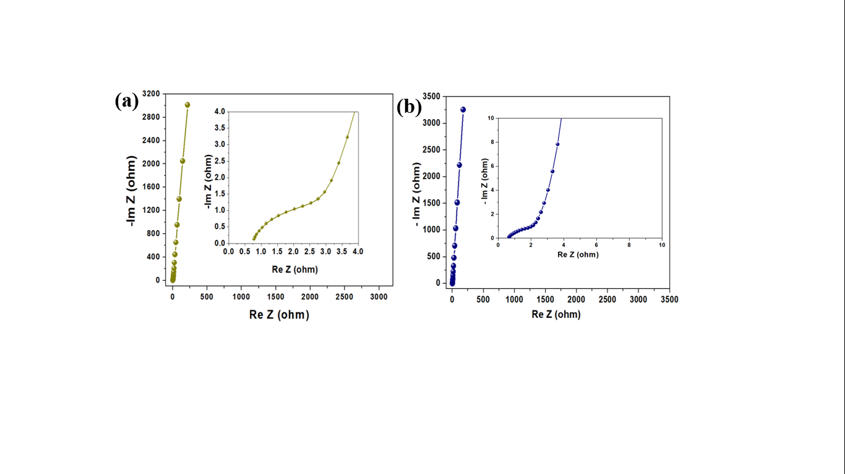

**Figure S3.** Nyquist plot of the T-Nb2O5-based SSD **(a)** before and; **(b)** after the cyclic stability test.